**LOVELY PROFESSIONAL UNIVERSITY**



***COURSE CODE:*** INT306.

***COURSE NAME:*** Database Management System.

***PROJECT TITLE:*** Stock Analysis.

***“Department of Computer Science***

***&***

***Engineering”***

***SUBMITTED TO***: Prof. Karthick Panneerselvam ***.***

***SUBMITTED BY:***

|  |  |
| --- | --- |
| NAME | V.KOUSHIK. |
| SECTION | K21ZN. |
| ROLL NUMBER | RK21ZNA11. |
| REGISTRATION NUMBER | 12112291. |

***TABLE OF CONTENTS:***

**Abstract…………………………………………………………………………………...3**

**Acknowledgement…………………………………….…………………………………..4**

**Introduction……………………………………………….……………………………....5**

**Project Description……………………………………………..…………………………6**

**Entities and Attributes……………………………………………..……………………..8**

**E-R Diagram……………………………………………………………………………..10**

**Schema diagram………………………………………………………………………….11**

**My SQL code…………………………………………………………….………………..13**

**PL/SQL code…………………………………………………………………….………..23**

**Conclusion………………………………………………………………………………...26**

***ABSTRACT:***

The Stock Analysis facilitates with purchasing and selling of the stocks and inquire about the stocks available on the market to the user. The aim of the case study is to design and develop a database maintaining the records of shares of different companies and the people who buy and sell stocks, to keep the data about value of the stock in different currencies.

This project contains Introduction to stock analysis. It is the computerized system of purchasing the stocks and keeping the data of the stocks by doing an analysis upto date. By using these platform all information about the stocks is available at one platform which makes it easier for user to know about the value of shares in the market.

In our country, there are number of platforms to avail information about the stock market analysis. Then this project contains entity relation model diagram based on stock market analysis and introduction to relation model. There is also design of database of stock analysis based on relation model example of some SQL queries to retrieve data from stockmarket database.

This project contains SQL queries screenshots of the queries made in the platform my SQL using database “ stockmarket”.

***ACKNOWLEDGEMENT:***

First and foremost, we would like to express our gratitude to our Professor, who was a continual source of inspiration. He pushed us to think imaginatively and urged us to do this homework without hesitation. His vast knowledge, extensive experience, and professional competence in Database Management Systems enabled us to successfully accomplish this project. This endeavor would not have been possible without his help and supervision. We could not have asked for a finer mentor in our studies.

I’d like to thank The Lovely Professional University for providing me with the opportunity to work on the project for **“Stock Analysis.”** Last but not least, I would like to express my gratitude to my friends for their invaluable assistance, and I am deeply grateful to everyone who has contributed to the successful completion of this project.

***INTRODUCTION:***

A database is an organized collection of data. The data is typically organized to model aspects of reality in a way that supports processes requiring information. A DBMS makes it possible for end users to create, read, update, and delete data in a database. The DBMS essentially serves as an interface between the database and end users or application programs, ensuring that data is consistently organized and remains easily accessible. The DBMS manages three important things: the data, the database engine that allows data to be accessed, locked, and modified, and the database schema, which defines the database’s logical structure. These three foundational elements help provide concurrency, security, data integrity, and uniform administration procedures. The DBMS can offer both logical and physical data independence. That means it can protect users and applications from needing to know where data is stored or being concerned about changes to the physical structure of data.

The main goal of keeping a database for stock analysis is to reduce the manual errors involved in buying and selling stocks and to make it easier for users and buyers to keep track of their transactions, the value of their shares, and how many shares they own. Due to automation, many loopholes that exist in the manual maintenance of the records can be removed. The speed of obtaining and processing the data will be fast. For future expansion, the proposed system can be web-enabled so that the buyers and users can make various purchases. Due to this, sometimes a lot of problems occur, and they are facing many disputes with clients. To address the aforementioned issue, we create a database that includes user information, the market price of stocks, and the number of companies and their details.

***PROJECT DESCRIPTION:***

This project is about creating the database about Stock Analysis.

The Stock Analysis facilitates with purchasing and selling of the stocks and inquire about the stocks available on the market to the user. The aim of the case study is to design and develop a database maintaining the records of shares of different companies and the people who buy and sell stocks, to keep the data about value of the stock in different currencies. The record of stocks include the no of companies, different currencies, their industry, avail shares, prices, members or users and their balance. All these data in the Database help the user understand his purchasing power and amount of his shares in his account better.

Stock MarketAnalysis of stocks using data mining will be useful for new investors to invest in stock market based on the various factors considered by the software**.**

Stock market includes daily activities like Sensex calculation, exchange of shares. The exchange provides an efficient and transparent market for trading in equity, debt instruments and derivatives.

Our software will be analysing Sensex based on company’s stock value. The stock values of company depend on some of the following factors:

* ***Currency value:*** The fluctuations in the Currency value day by day will be playing crucial part in the stock values of companies (basically I.T based companies) The impact of Currency values will be different for different companies.
* ***Corporate results:*** This will be regarding to the profits or progress of the company over a span of time say 3 months.
* ***Inflation:*** The overall rise in price of all the products which affects purchasing power.

The stock value depends on other factors as well, but we are taking into consideration only these particular factors.

List of stock companies has to be maintained. Detailed information is to be maintained in the account of the users while purchasing as the error can effect the user very much.

On the basis of the values provided by the clients corresponding data in the records of the database can be altered or changed. If aa buyer wants to buy shares his profile is scanned and the offered price is sent to the user or client of the company. The records can be deleted by the company if they desire the change.

***ENTITIES AND ATTRIBUTES:***

|  |  |
| --- | --- |
| Entities | Attributes |
| member | mid (primary key)  mname  pass  balance |
| shares | inv_amt  quantity  gain  t_gain  u_id  curr_price  comp_name |
| Member_currency | int_amt  quantity  gain  t_gain  u_id  c_price  c_name |
| Member_commodity | inv_amt  no_units  gain  tgain  u_id  unit  cm_price  cm_name |

|  |  |
| --- | --- |
| Entities | Attributes |
| Company | comp_name(primary key)  curr_price  industry  t_shares  oldprice  diff  avail_share  product |
| commodity | cm_name (primary key)  cm_price  unit  omname  diff |
| currency | c_name(primary key)  c_price  oprice  diff |
| administrator | admin_name (primary key)  admin_pass |

***ER DIAGRAM:***

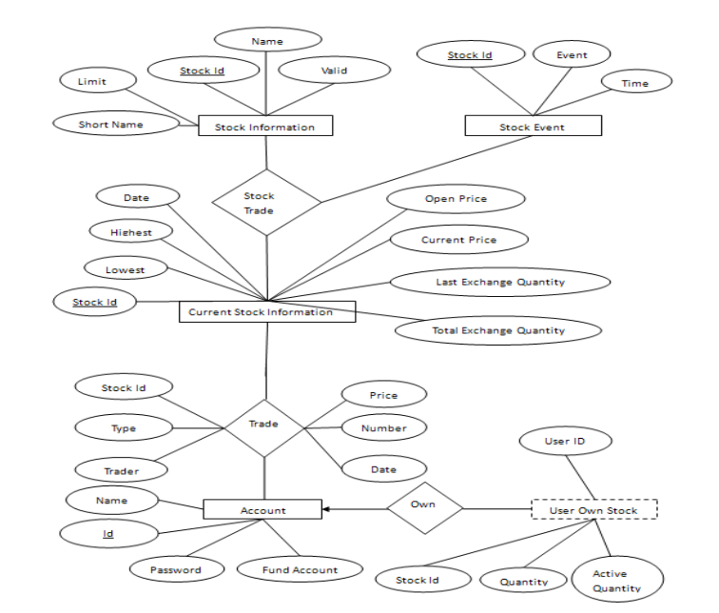

***SCHEMA DIAGRAM:***

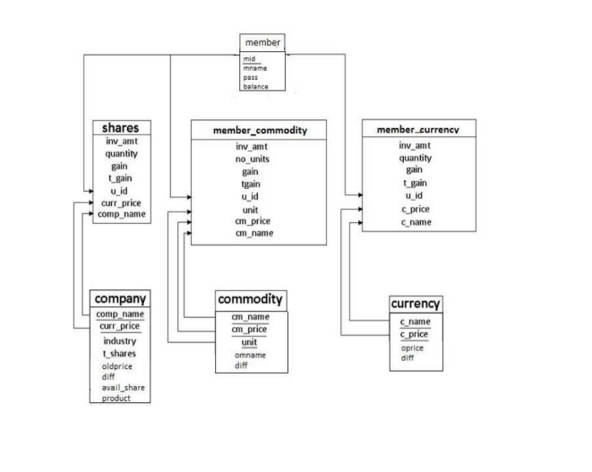

Stock analysis Schema diagram

***SCHEMA DIAGRAM:***

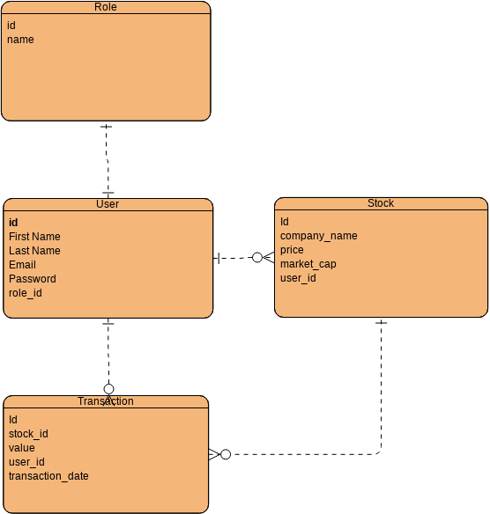

***MY SQL CODE:***

create database stockmarket;

use stockmarket;

create table member

(

mid int,

mname varchar(20),

pass varchar(10),

balance numeric(20,5),

primary key(mid)

);

create table currency

(

cname varchar(20),

cprice float(2),

oprice float(2),

diff float(2),

primary key(cname,cprice)

);

create table member_currency

(

mid int ,

cname varchar(20),

cprice float(2),

quantity int,

invest_amt float(2),

gain float(2),

tgain float(2),

foreign key(mid) references member(mid)

ON UPDATE CASCADE

on delete cascade,

foreign key(cname,cprice) references currency(cname,cprice)

on update cascade

on delete cascade

);

create table commodity

(

cmname varchar(20),

cmprice float(2),

oprice float(2),

diff float(2),

unit varchar(10),

primary key(cmname,cmprice,unit)

);

create table member_commodity

(

mid int,

cmname varchar(20),

cmprice float(2),

invest_amt float(2),

quantity int,

unit varchar(10),

gain float(2),

tgain float(2),

foreign key(mid) references member(mid)

on update cascade

on delete cascade,

foreign key(cmname,cmprice,unit) references commodity(cmname,cmprice,unit)

on update cascade

on delete cascade

);

create table company

(

comp_name varchar(50),

industry varchar(50),

tshares int,

curr_price float(2),

old_price float(2),

diff float(2),

avail_shares int,

product numeric(15,4),

primary key(comp_name,curr_price)

);

create table shares

(

mid int,

comp_name varchar(50),

curr_price float(2),

invest_amt float(2),

quantity int,

gain float(2),

tgain float(2),

foreign key(mid) references member(mid)

on update cascade

on delete cascade,

foreign key(comp_name,curr_price) references company(comp_name,curr_price)

on update cascade

on delete cascade

);

create table administrator

(

admin_name varchar(20),

admin_pass varchar(10),

primary key(admin_name)

);

INSERT SQL VALUES:

insert into member values (11111, 'Prajakta Shinde','abc',100000.00);

insert into member values (22222, 'Hiral Shah','123',50000.00);

select* from member;

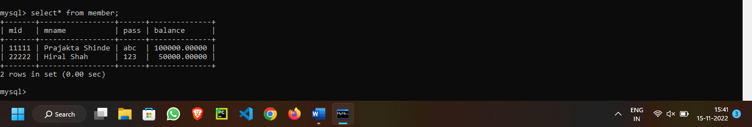

insert into currency values ('US $/Rupee',55.2,0.0,0.0);

insert into currency values ('Euros/Rupee',69.4,0.0,0.0);

insert into currency values ('AUS $/Rupee',52.72,0.0,0.0);

insert into currency values ('Japenese yen/Rupee',0.62,0.0,0.0);

insert into currency values ('Renminbi/Rupee',8.12,0.0,0.0);

insert into currency values ('Pounds/Pupee',85.8,0.0,0.0);

insert into currency values ('Dirhams/Rupee',14.00,0.0,0.0);

insert into currency values ('singapore $/Rupee',43.77,0.0,0.0);

insert into currency values ('Taiwan $/Rupee',1.82,0.0,0.0);

insert into currency values ('Ringgit/Rupee',15.67,0.0,0.0);

select* from currency;

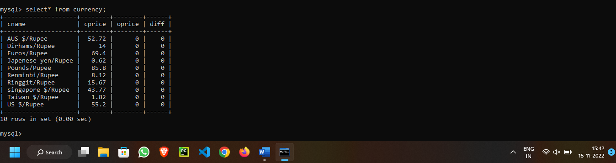

insert into commodity values ('Gold',28345.62,0.0,0.0,'10 gm');

insert into commodity values ('Silver',55500.2,0.0,0.0,'kg');

insert into commodity values ('Crudeoil',5237,0.0,0.0,'barrel');

insert into commodity values ('Copper',435.5,0.0,0.0,'kg');

insert into commodity values ('Zinc',102.10,0.0,0.0,'kg');

insert into commodity values ('Lead',113.69,0.0,0.0,'kg');

insert into commodity values ('Nickel',910.45,0.0,0.0,'kg');

insert into commodity values ('Aluminium',106.80,0.0,0.0,'kg');

insert into commodity values ('Natural Gas',194.80,0.0,0.0,'kg');

insert into commodity values ('Cotton',16790.65,0.0,0.0,'kg');

select* from commodity;

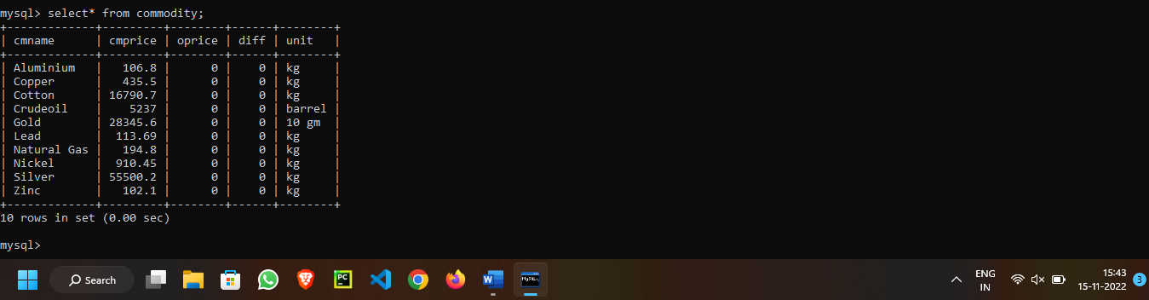

insert into company values('Cipla','Pharmaceuticals', 56000, 105.25,0.0,0.0,40000,0.0);

insert into company values('Wipro','Information Technology', 100000, 65.23,0.0,0.0,80000,0.0);

insert into company values('ICICI Bank','Banking',70000,362.14,0.0,0.0,60000,0.0);

insert into company values('Mahindra & Mahindra','Automotive', 60000, 203.16,0.0,0.0,45000,0.0);

insert into company values('Tata Power','Power', 20000, 70.36,0.0,0.0,10000,0.0);

insert into company values('Reliance Industries','Oil and gas', 90000, 513.64,0.0,0.0,75000,0.0);

insert into company values('DLF','Real estate',65000,220.5,0.0,0.0,50000,0.0);

insert into company values('Sterlite Industries','Metals and Mining', 80000, 80.45,0.0,0.0,62000,0.0);

insert into company values('Infosys','Information Technology', 75000, 110.89,0.0,0.0,58000,0.0);

insert into company values('Bharti Airtel','Telecommunication', 50000, 1050.21,0.0,0.0,43000,0.0);

insert into company values('State Bank Of India','Banking', 32000, 165.91,0.0,0.0,25000,0.0);

insert into company values('Oil and Natural Gas Corporation','Oil and gas', 30000,60.95,0.0,0.0,20000,0.0);

insert into company values('Jindal Steel & Power','Steel & Power', 75000,254.123,0.0,0.0,64000,0.0);

insert into company values('Maruti Suzuki','Automotive', 85000, 756.46,0.0,0.0,72000,0.0);

insert into company values('Hindustan Unilever','Consumer goods', 45000,564.78,0.0,0.0,31000,0.0);

UPDATE company

SET product=avail_shares*curr_price;

select * from company;

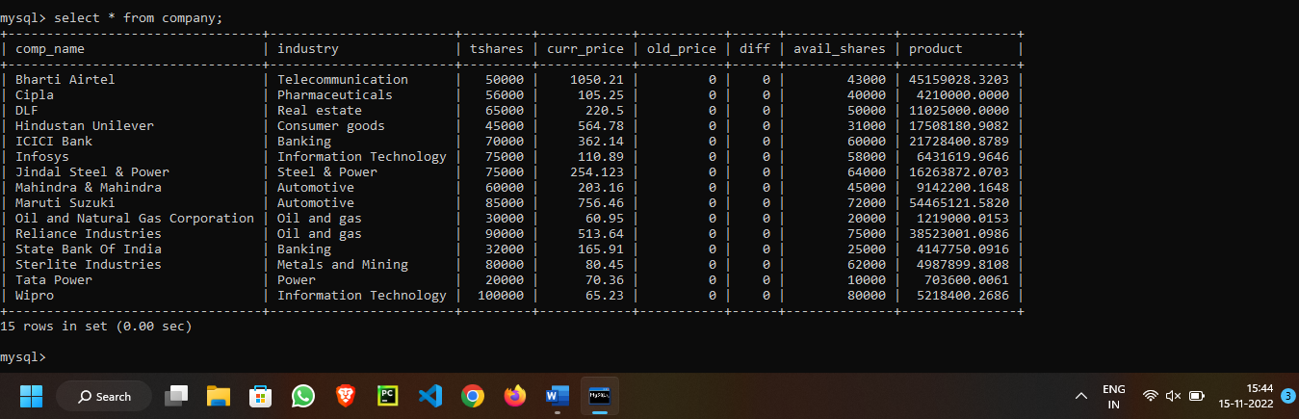

CREATE VIEW comp

AS

SELECT comp_name,industry,avail_shares,curr_price,diff

FROM company;

select * from comp;

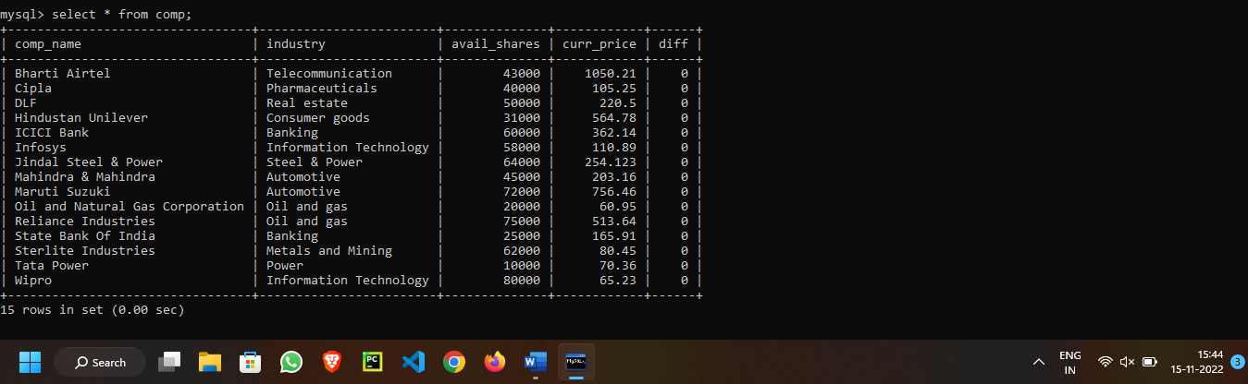

insert into member_currency values(11111,'AUS $/Rupee', 52.72, 50, 50.32, 0, 0);

insert into member_currency values(11111,'US $/Rupee', 55.2, 50, 58.56, 0, 0);

insert into member_currency values(11111,'Ringgit/Rupee', 15.67, 50, 16.75, 0, 0);

insert into member_currency values(22222,'AUS $/Rupee', 52.72, 50, 53.58, 0, 0);

insert into member_currency values(22222,'Pounds/Pupee', 85.8, 75, 86.68, 0, 0);

insert into member_currency values(22222,'Ringgit/Rupee', 15.67,80, 14.77, 0, 0);

insert into member_commodity values(11111,'Gold', 28345.62, 27468.32, 7,'10 gm', 0, 0);

insert into member_commodity values(11111,'Copper', 435.5, 440.3, 5,'kg', 0, 0);

insert into member_commodity values(22222,'Silver', 55500.2, 55515.66, 0.5,'kg', 0, 0);

insert into member_commodity values(22222,'Cotton', 16790.65, 15398.52, 3,'kg', 0, 0);

select* from member_commodity ;

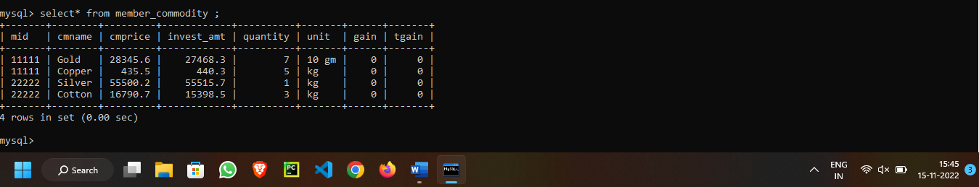

insert into shares values(11111,'Wipro', 65.23, 68.8, 100, 0, 0);

insert into shares values(11111,'Cipla', 105.25, 106.43, 80, 0, 0);

insert into shares values(11111,'DLF', 220.5, 218.94, 25, 0, 0);

insert into shares values(11111,'ICICI Bank', 362.14, 363, 50, 0, 0);

insert into shares values(11111,'Infosys', 110.89, 109.3, 60, 0, 0);

insert into shares values(11111,'Mahindra & Mahindra', 203.16, 200.9, 45,0, 0);

insert into shares values(11111,'Reliance Industries', 513.64, 513.1, 105, 0, 0);

insert into shares values(22222,'Bharti Airtel', 1050.21, 1045.3, 40, 0, 0);

insert into shares values(22222,'Wipro', 65.23, 66.8,90, 0, 0);

insert into shares values(22222,'Jindal Steel & Power', 254.123, 255, 60, 0, 0);

insert into shares values(22222,'Maruti Suzuki', 756.46, 755.4, 50, 0, 0);

insert into shares values(22222,'Hindustan Unilever', 564.78, 564.3, 30, 0, 0);

insert into shares values(22222,'Tata Power', 70.36, 69.8, 100, 0, 0);

select* from shares;

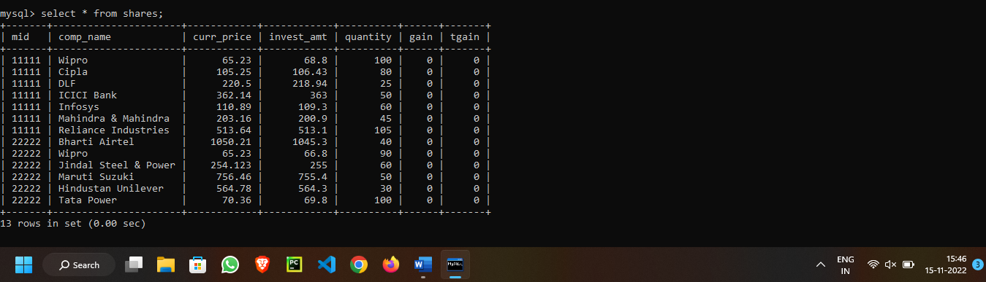

insert into administrator values('Koushik123','777');

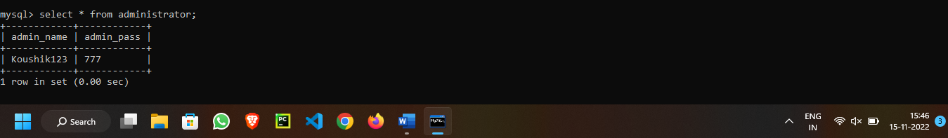

UPDATE:

update member_currency

set gain=cprice-invest_amt;

update member_currency

set tgain=gain*quantity;

update member_commodity

set gain=cmprice-invest_amt;

update member_commodity

set tgain=gain*quantity;

update shares

set gain=curr_price-invest_amt;

update shares

set tgain=gain*quantity;

show tables;

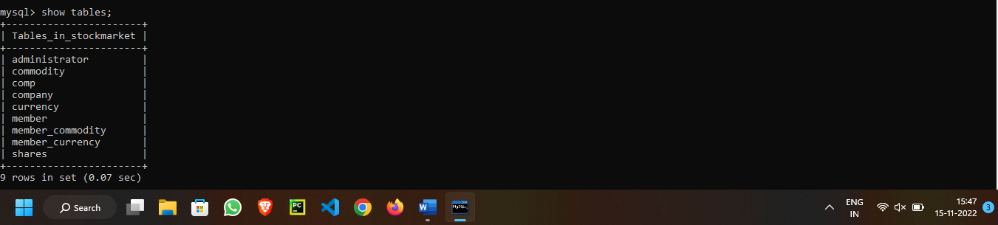

***PL-SQL CODE:***

create table company(ID int,comp_name varchar(30), Industry varchar(20),curr_price float(2),primary key(comp_name));

insert into company values(1,'Reliance Industries','Oil and gas', 90000);

insert into company values(2,'DLF','Real estate',65000);

insert into company values(3,'Sterlite Industries','Metals and Mining', 80000);

DECLARE

cnt number(3);

BEGIN

UPDATE company set curr_price=curr_price+15000 where ID=2;

cnt:=SQL%ROWCOUNT;

dbms_output.put_line(cnt || 'rows updated');

END;

/

select*from company;

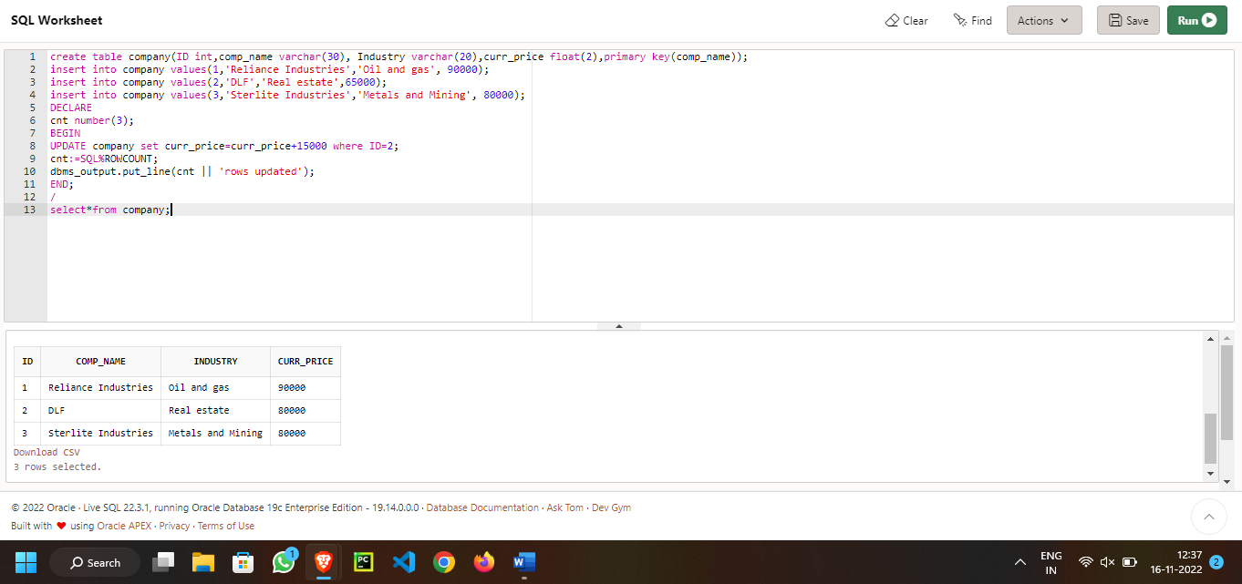

Trigger in PL/sql:

CREATE OR REPLACE TRIGGER display_oldprice_changes

BEFORE UPDATE ON company

FOR EACH ROW

WHEN (NEW.ID > 0)

DECLARE

price_diff number;

BEGIN

price_diff := :NEW.curr_price - :OLD.oldprice;

dbms_output.put_line('Old price: ' || :OLD.oldprice);

dbms_output.put_line('New price: ' || :NEW.curr_price);

dbms_output.put_line('Salary difference: ' || price_diff);

END;

/

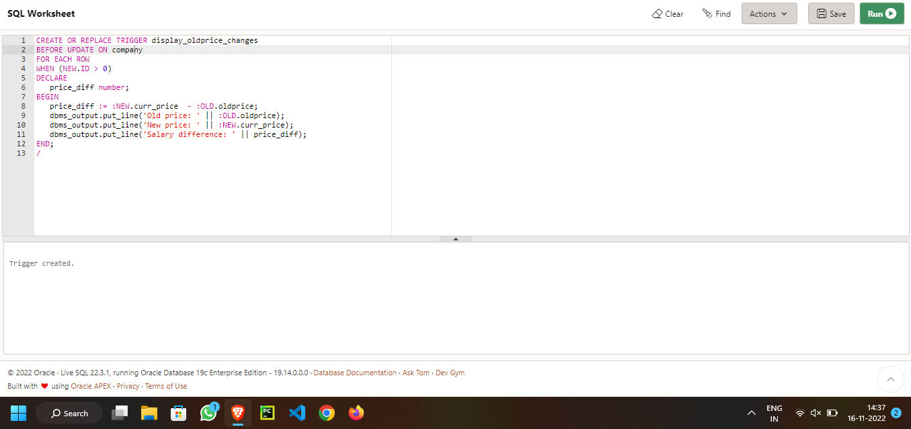

Checking diff by procedure.

DECLARE

total_rows number(2);

BEGIN

UPDATE company

SET oldprice = oldprice + 5000;

IF sql%notfound THEN

dbms_output.put_line('no customers updated');

ELSIF sql%found THEN

total_rows := sql%rowcount;

dbms_output.put_line( total_rows || ' customers updated ');

END IF;

END;

/

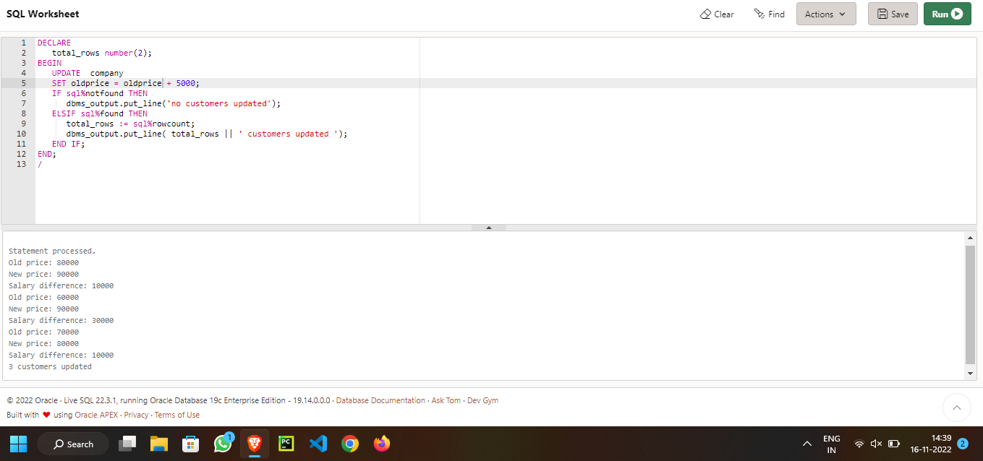

***CONCLUSION:***

In our project Stock Analysis we have stored all the information about the Stocks and the users buying stock. This data base is helpful for the applications which facilitate clients to buy the stocks and check the details of companies and their status from their price. We had considered the most important requirements only, many more features and details cand be added to our project in order to obtain even more user friendly applications. These applications are already in progress and in future they can be upgraded and may become part of amazing technology.